2014-FI-02-EN-edit2 Hotel rooms keys
0 ---- | I: ---- | II: hard | III: hard | IV: medium

Answer Type: Multiple Choice Mandatory for: none

Body

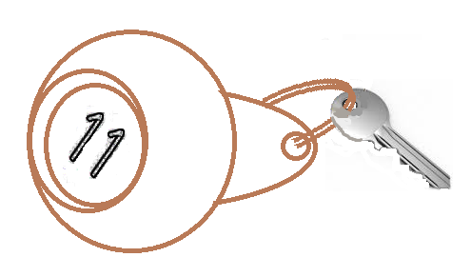
In a hotel, the rooms are numbered with two digits. The first digit indicates on which floor the room is located; the second digit indicates the distance from the elevator to the room.

A customer comes and asks for a room, but he really does not want to walk much. So any room which takes less walking to reach it is better than a room with more walking. If multiple rooms involve the same amount of walking, the customer prefers the lower floor.

Question

Sort the available room keys based on how much the customer would like them. On the left you should place the room key that the customer will like the best; on the right the room key that he likes the least.

The following room keys are available: 12, 25, 11, 43, 22, 15, 18, 31, 44, 52

Answer

A. 18, 15, 12, 11, 25, 22, 31, 44, 43, 52
B. 52, 43, 44, 31, 22, 25, 11, 12, 15, 18
C. 11, 31, 12, 22, 52, 43, 44, 15, 25, 18
D. 11, 12, 15, 18, 22, 25, 31, 43, 44, 52

Explanation

C is the correct answer. The receptionist sorted the keys as he would have read the numbers from right to left (second digit before first digit). If the numbers are read this way, the keys in answer C are sorted in ascending order from left to right.

A is wrong because already the first two key numbers (18 and 15) are not sorted correctly according to the previously mentioned method.

B is wrong because the third and the fourth key numbers (44 and 31) are not ordered correctly.

D is wrong because it is sorted by the floors.

It's informatics

In computer science, radix sort is a non-comparative integer sorting algorithm that sorts data with integer keys by grouping keys by the individual digits which share the same significant position and value. A positional notation is required, but because integers can represent strings of characters (e.g., names or dates) and specially formatted floating point numbers, radix sort is not limited to integers. Radix sort dates back as far as 1887 to the work of Herman Hollerith on tabulating machines.

Keywords

Sort, radix sort

Websites

http://en.wikipedia.org/wiki/Radix_sort

Internal Use

Wording

Comments

Author, e-mail, Date (YYYY-MM-DD), Comment.

Graphics

2014-FI-02-Key.svg (done by Sergei Pozdniakov at the workshop)

Files

All additional files for this task (graphics, scripts, etc.)
2014-FI-02-EN-edit2.odt (this file)
2014-FI-02-Key.svg

Authorship

Juha Vartiainen, juha.vartiainen@gmail.com , Finland
Linda Mannila, linda.mannila@abo.fi, Finland
Peter Garscha, peter@rlsux.com, Austria
Sergei Pozdniakov, pozdnkov@gmail.com, Russia
Khairul M. Zaki khairul@aidan.com.my
Eljakim Schrijvers eljakim@gmail.com

License

Copyright © 2014 Bebras – International Contest on Informatics and Computer Fluency. This work is licensed under a Creative Commons Attribution-NonCommercial-ShareAlike 3.0 Unported License (CC BY-NC-SA 3.0). Visit: http://creativecommons.org/licenses/by-sa-sa/3.0/

